**Correcting a Service**

**Overview**

This procedure outlines the process for making an edit to a service that has already been submitted. *Please note the difference between a service that is in approved, batched, or paid vs complete status

# Correcting a Service Procedure

If the service that needs corrections has already been billed:

1. Email Admin and CC your supervisor to unprocess the service.

If the service that needs correction and is in ***approved, batched or paid***status:

1. Open the service that needs correction.
   1. **Clinical Updates** (updates made to the body of the service)
      1. Click **Edit Full Visit**
      2. 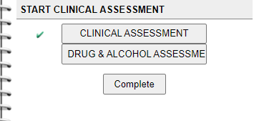Click the form you wish to update
      3. 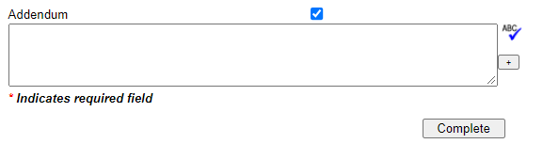Make changes in the Addendum section of the form (DO NOT change the body of the note within the other fields)
      4. Once changes are added to the Addendum box, click **Complete**.
   2. **Billing Strip Updates:**
      1. Click **Update**
      2. Make changes indicated by the Red X
      3. Uncheck the “Set Manual Red X” box (goes from blue with a white check, to a white box), and *leave* the comment in the *Manual Red X Note* field. 
      4. Click **Update Service** at the bottom of the screen.

If the service that needs correction and is in ***complete***status (you have submitted the service, but it has not yet been approved, batched, or billed):

1. Open the service that needs correction.
   1. **Clinical Updates** (updates made to the body of the service)
      1. Click **Edit Full Visit**
      2. Click the form you wish to update
      3. Make changes *within* the body of then note in the text boxes (no need to use the Addendum Box)
      4. Click **Complete** once changes are made.
2. **Billing Strip Updates:**
   1. Click **Update**
   2. Make changes indicated by the Red X
   3. Uncheck the “Set Manual Red X” box (goes from blue with a white check, to a white box), and *leave* the comment in the *Manual Red X Comment* field.
   4. Click **Update Service** at the bottom of the screen.