Approving a Service Procedure

## **Overview**

A service rendered to The Client must be approved before it can be billed.

**Approving a Service Procedure**

When the System validates the service documentation against Billing Rule Sets. If the service does NOT meet all of the billing rule sets, the service will be flagged with a Red X.

When Admin/Supervisor adds a Manual Red X

1. Log into Credible
2. Click **Service** tab

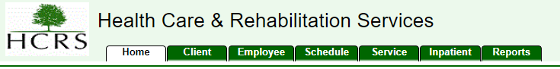

1. Filter service list by “Multi-Stage”
   1. Select “*My Multi-Stage*” from the drop down
   2. Select program/team you’re assigned to (you may have to filter multiple times for each program/team you are assigned to)
   3. 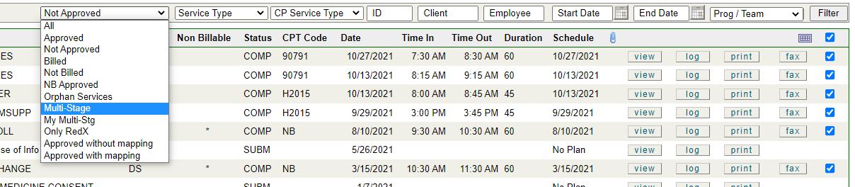Click **Filter**
   4. 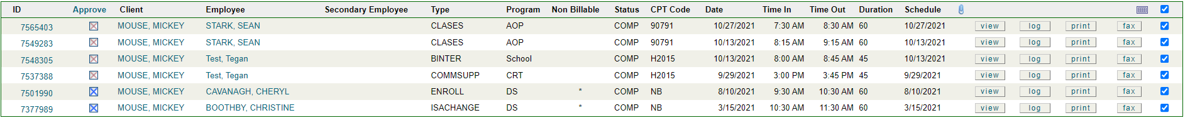Select Service that needs approval by clicking either the service number, or **View**
      1. Review the service (Supervisor)
         1. Sign if required by document by clicking **Sign**
         2. Set a Red X if corrections are needed
            1. Click Update



* + - * 1. Check Manual Red X Box
        2. Add concise comment including error & your initials to Manual Red X Note (Do NOT put your comment in the *Note* section below)
        3. Click **Update Service** on the bottom of the screen

1. Notify the original author of the service (the provider):
   1. Area Manager: Set a To-Do if required by program
   2. Admin: Set a Red X
      1. See Admin Approval Audit Checklist
      2. See Billing Approval Audit Checklist

Multi-stage Approval (Blue X): some services require Multi-Stage Approval where more than the provider is required to audit and approve the service documentation for completion and accuracy, or for additional signatures.

Complete steps 1-4 above

1. If the note has no errors, click **Approve**

6. Once approved, a Blue X will appear, it moves to the next level of the multi-stage approval process. *